**POWER BI - Average Time Spent By A User On Social Media Dashboard**

**Objective :** This Project aims to analyze user activity on social media platforms (i.e, Instagram, Facebook and YouTube) to understand engagement patterns, demographics and user behavior with the aim of optimizing marketing strategies and improving user experience.

**Dataset Overview and Data Processing:** Dummy Dataset from Kaggle [Average Time Spent By A User On Social Media (kaggle.com)](https://www.kaggle.com/datasets/imyjoshua/average-time-spent-by-a-user-on-social-media) in Excel Format. Dataset contains below columns

* **age:** The age of the user.
* **gender:** The gender identity of the user (Male, Female, Non-binary).
* **demographics:** The type of area the user resides in (Urban, Suburban, Rural).
* **interests:** The user's primary area of interest or hobby.
* **device_type:** The type of device used by the user (Mobile).
* **location:**The country of residence for the user.
* **platform:** The social media platform where the user spends time.
* **profession:** The user's occupation or professional status.
* **income:** The yearly income of the user.
* **indebt:** Indicates whether the user is in debt (True or False).
* **homeowner:** Indicates whether the user owns a home (True or False).
* **owns_cars:** Indicates whether the user owns cars (True or False).

**New Column with DAX Formula :**

A new column is added to dataset and named as Age group. DAX Formula involved in grouping age groups.

**Insights and Findings :** After analyzing user activity on social media, several key insights were uncovered. Firstly, users below 31 age group are tend to spend most time on social media, particularly on platforms like Instagram and Facebook. Additionally, there is a significant gender disparity, males users are more on social media compared to females. Lastly, user with Marketer Manager profession exhibit higher levels of engagement.

**Steps to create Dashboard:**

1. Import Data from Excel:

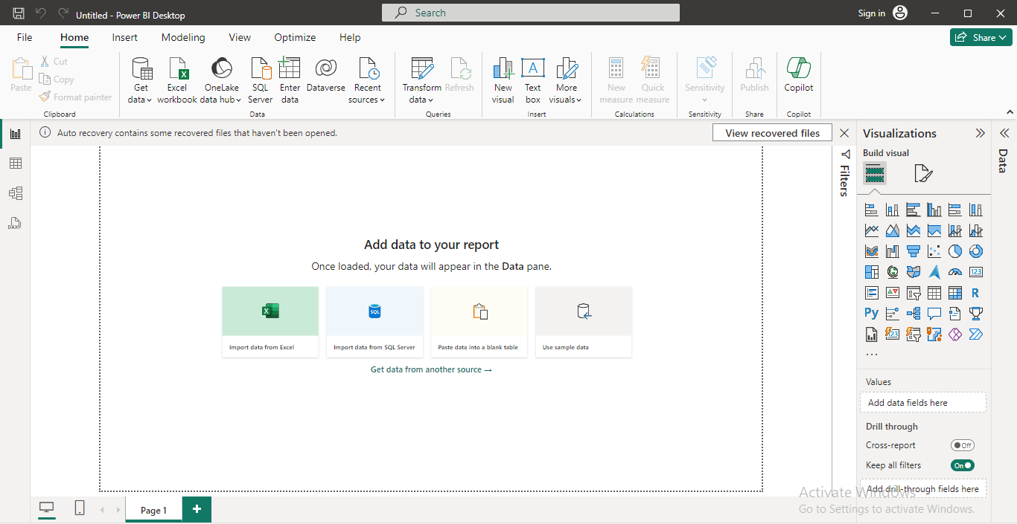

1. Select the required table (dummy_data) and click on Load.

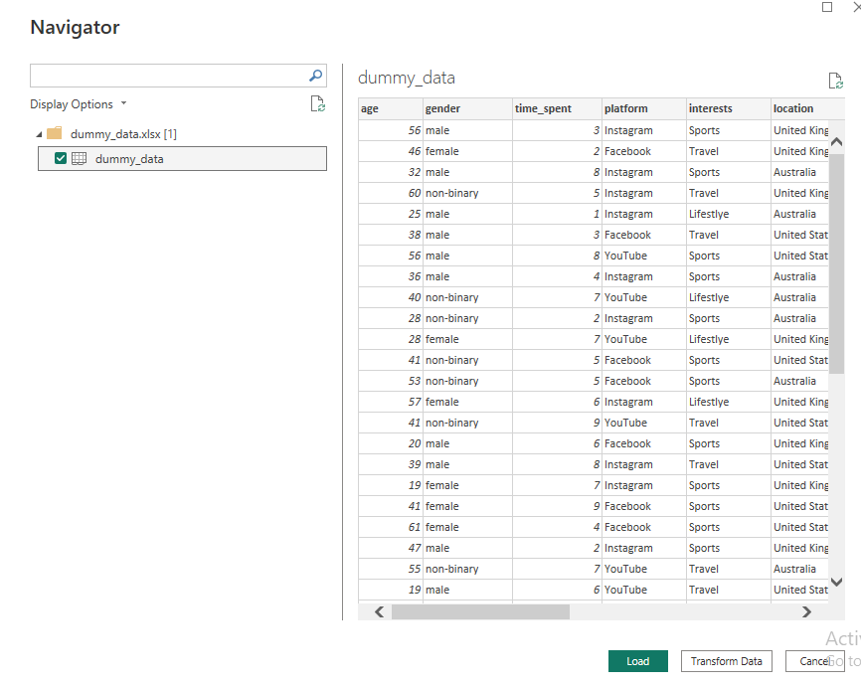

1. Once loaded Select the **Clustered column chart** Visual and select the columns below from dummy_data Table.

* Platform
* Average of Time_Spent

Visual looks like this

1. Select a **Card** Visual and select ‘Gender’ column from dummy_data table. Visual looks like this.

Count of users will be displayed

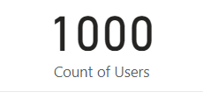

1. Select **Line Chart** Visual and add below columns:

• Age Group and Time Spent from dummy_data table.

Visual looks like this

Age Group is a **new column** added in dataset by using **DAX formula.**

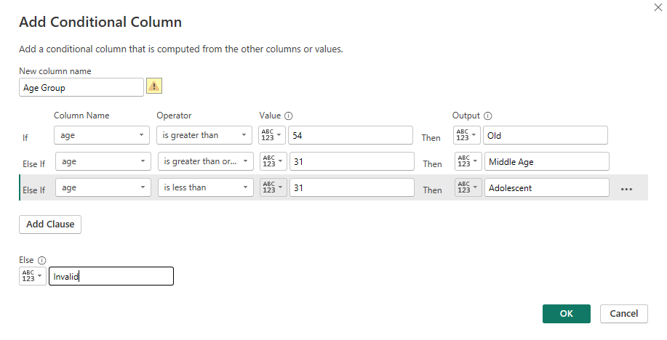

1. Select **Donut Chart** Visual and add below column:

* Gender

Visual looks like this

1. Select **Treemap** Visual and add below column;

* Profession
* Time Spent

Visual looks like this

1. Select **Map** and add below column

* Location

Visual looks like this

